**PrintAhead Online**

The following describes changes to be made to PrintAhead 2.0 to the new online app. The most basic change is that there is no need to change the UI as all interaction will be done via a web page (see enclosed separate document PrintAhead Online PRD).

**What is the objective of the new version?**

The objective is twofold:

1. Create an online version where the user builds the output and orders statues, not just files.
2. Along with the new objective, the output needs to be “desirable”, something that people will pay money for to put in their living room. To that extent new hairs and busts are created that eliminates the stark image of “beheaded” people.

**Changes.**

1. Accessories ($100) Need it ASAP!!!

As a very first step, the category/tab “Accessories” needs to be put back. This folder will contain the busts that will be added to the statue. I will need a new build with Accessories tab ASAP to test new statues. Also, please place all folders (currently in User/Documents/Abalone) to inside the app folder and re-direct links to the new location.

1. Head/Neck Attached ($150) Need it ASAP!!!

Connection between head and neck is problematic (as the shape of head changes, neck does not fit precisely). Replace old models (Male, Female and Child) with new ones, where the head and neck are attached. If head shape changes, the neck changes with it. (I will upload the new head/neck meshes).

1. Fix Child issue ($100)

There’s an issue with the way some pictures morph with child. Please investigate/fix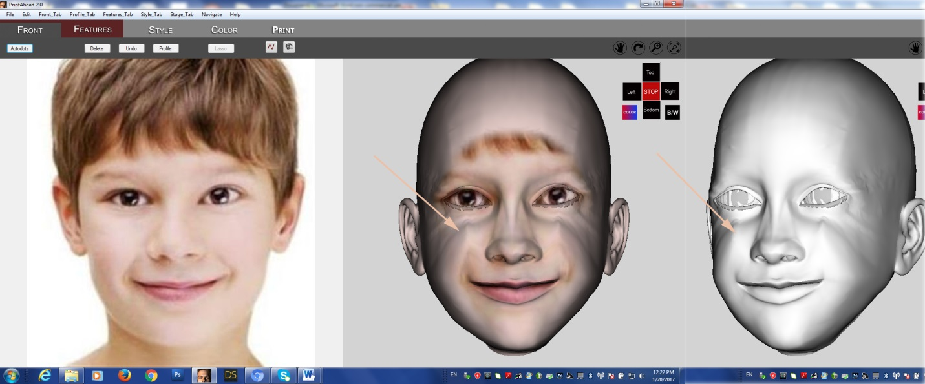

1. API calls ($200)

Create and implement API calls. The API calls will be coming from the web page and interact with the cloud application. (More details to come from web-master).

For example, when user browse/chooses a photo and loads into the web page, there will be an API call to load it to the cloud app.

When application produces a temp OBJ files into a temp folder, the web page will look for the latest tempOBJ file and loads it into a web viewer.

Similarly, when user chooses an option (different hair, color, or pedestal) API call will be sent to the app which amends the tempOBJ file.

1. Improve texture file more ($200)

Texture transition has improved much in from OneClick to PA 2.0. Still, there needs to be a smoother transition from background to texture. It is not an easy task but our competitor managed to do it (see below).

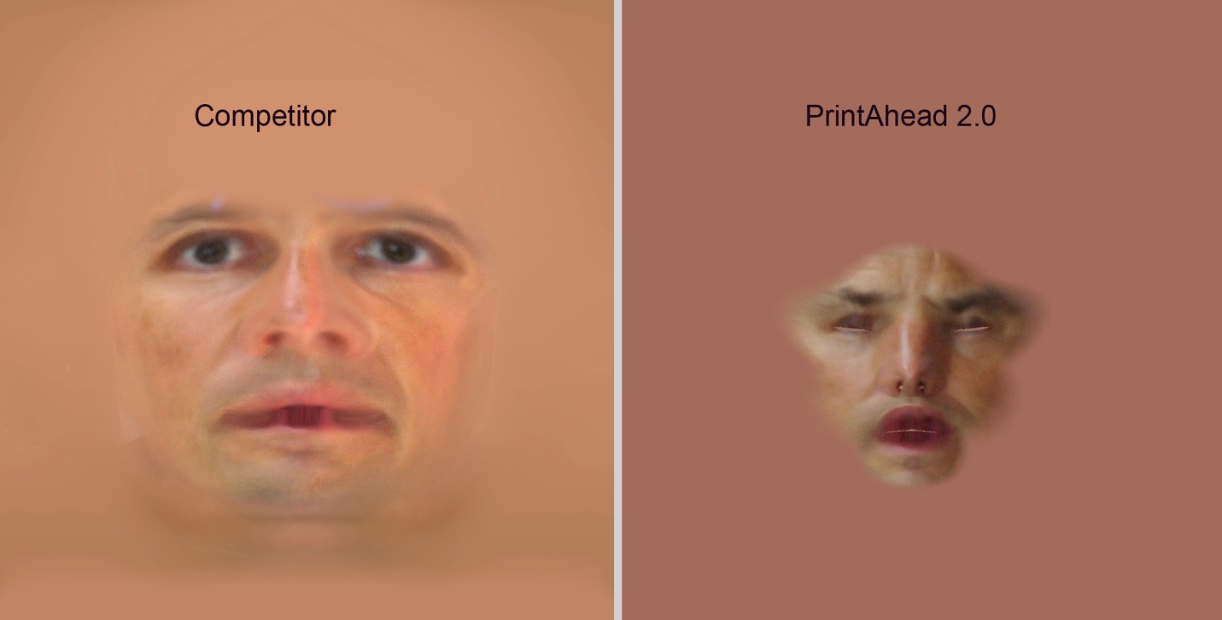

1. Bonus (if done by Feb 15): $200